**Women's September Holistic Retreat**

**Escape to an 'oasis cottage, in Port Franks - just minutes from picturesque Grand Bend, Ontario, and minutes from the beach on Lake Huron, for a transformative weekend dedicated to your well-being.**

**September 12 - 14**

**Join Karen Egoff & her guests September 12 - 14 in the Grand bend area minutes from the shores of beautiful Lake Huron for three days of Yoga, Wellness, Art & New Beginnings and of course lots and lots of fun.**

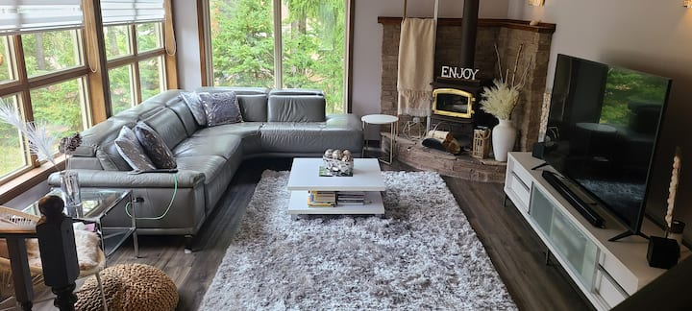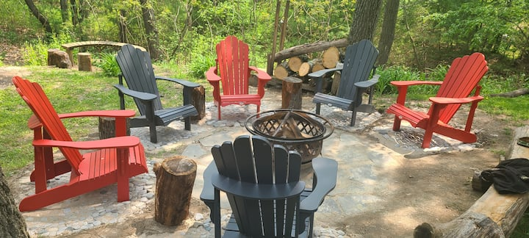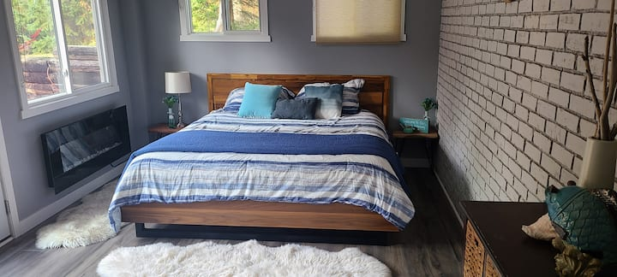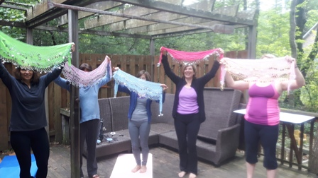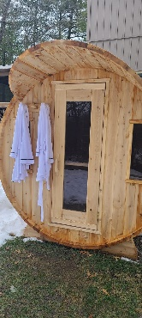

2 nights of serene accommodation in a beautiful, private oasis.

* Delicious, nutritious meals tailored to your preferences.

* Daily guided meditations and deeply restorative sound baths.

* Empowering workshops on facing fears, setting boundaries, and creating a personal pledge for self-care.

* Access to an invigorating sauna and a relaxing hot tub for ultimate unwinding.

* Ample time for relaxation, reflection, and rejuvenation.

**Rates: taxes in**

**Rates from $650-750. Includes Lodging, all Meals, and all Activities.**

**Private Sessions for Reiki, Cranial-Sacral available on request. Space is limited. Prices vary.**

**Reservations are required to assure your spaced and room request. Let us know if you have dietary restrictions. If you need to bring any special food, that is fine and we will alter prices accordingly. A list of what is included and what you need to supply will be forwarded.**

**Terms are 50% down for deposit, balance due August 15 or as you register.**

**…LIMITED SPACE ***** installments can be arranged.**

**For further information please contact:**

**Karen Egoff by email at karen.soulbalance@gmail.com Ph 519 496 1888**

**Our Web Site is www.mysoulbalance.com**